SWAPPING THE NUMBER USING VARIABLE

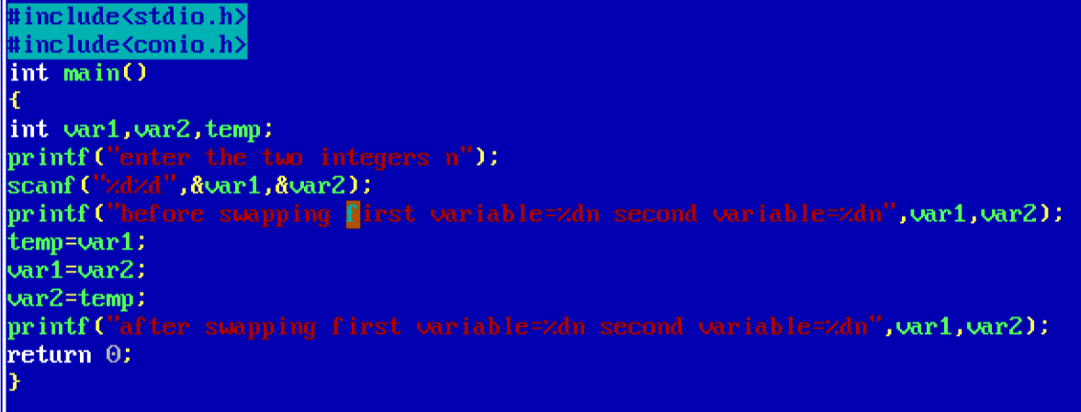

OUTPUT

